 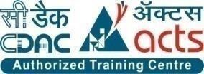

INSTITUTE FOR ADVANCED COMPUTING AND SOFTWARE DEVELOPMENT AKURDI, PUNE

Documentation On

“Employee Administration System”

PG-DAC SEPT 2022

**Submitted By:**

**Group No: 48**

**Roll No. Name:**

**229101 Supriya Sonawane**

**229117 Komal Dekate**

**Mr. Rohit Puranik Mrs. Geeta Darunte**

**Centre Coordinator Project Guide**

# ABSTRACT

An employee administration system is a software application designed to manage various aspects of employee information and data within an organization. The system allows for the tracking and monitoring of employee performance, training, benefits, payroll, and other relevant data.

The system can be used by HR managers, supervisors, and other authorized personnel to manage employee information, update employee records, and generate reports. It can also be used to automate various HR processes such as onboarding, performance appraisals, leave management, and more.

The employee administration system is typically a centralized database that is accessible by authorized personnel from different departments and locations within an organization. It is designed to ensure that employee data is secure, accurate, and up-to-date.

Overall, the employee administration system helps organizations to improve efficiency, reduce administrative workload, and enhance employee management processes.

An employee administration system is a software application designed to manage various aspects of employee information and data within an organization. The system allows for the tracking and monitoring of employee performance, training, benefits, payroll, and other relevant data.

The system can be used by HR managers, supervisors, and other authorized personnel to manage employee information, update employee records, and generate reports. It can also be used to automate various HR processes such as onboarding, performance appraisals, leave management, and more.

The employee administration system is typically a centralized database that is accessible by authorized personnel from different departments and locations within an organization. It is designed to ensure that employee data is secure, accurate, and up-to-date.

Overall, the employee administration system helps organizations to improve efficiency, reduce administrative workload, and enhance employee management processes.

# ACKNOWLEDGEMENT

I take this occasion to thank God, almighty for blessing us with his grace and taking our endeavor to a successful culmination. I extend my sincere and heartfelt thanks to our esteemed guide, **Mrs. Geeta Darunte** for providing me with the right guidance and advice at the crucial juncture sand for showing me the right way. I extend my sincere thanks to our respected **Centre Co-Ordinator Mr. Rohit Puranik**, for allowing us to use the facilities available. I would like to thank the other faculty members also, at this occasion. Last but not the least, I would like to thank my friends and family for the support and encouragement they have given me during the course of our work.

**Supriya Sonawane (229101)**

**Komal Dekate (229117)**

**INDEX**

ABSTRACT 2

ACKNOWLEDGEMENT 3

* 1. INTRODUCTION 6

1.1 Problem Statement 7

1.2 Product Scope 8

1.3 Aims & Objectives 9

2. SYSTEM ANALYSIS 10

2.1 Product Perspective10

2.2 Praposed System 10

* 1. Benefits of Employee Administration System 11
  2. Uses and Characteristics 12
  3. Operative Environment 13
  4. Design and Implementation Constraints  14

1. SPECIFIC REQUIREMENT 15

3.1 External Interface Requirements 15

1. SYSTEM DESIGN16

4.1 Input and Output Design 16

5. DATABASE DESIGN 17

* 1. Database………………………………………………………….……..17

5.2 System Tools 17

1. TABLE STRUCTURE19
2. SYSTEM DIAGRAMS20
   1. Activity Diagram 20

7.2.1 Zero Level DFD………………………………………………..……..21

7.2.2 First Level DFD………………………………………………..….….22

7.2.3 Second Level DFD………………………………………….….……..23

7.3. Class Diagram……………………...…………...……….………….….24

7.4 UseCase Diagram……………………………………………………....25

7.5.1 Add Employee Sequence Diagram 26

7.5.2 Employee Leave Application Sequence Diagram 27

7.5.3 Login of User Sequence Diagram 28

7.5.4 Add Salary Sequence Diagram 29

7.6.1 ER Diagram……………………..……...……………….…..……..….30

7.6.2 ER Diagram System Generated…....…………………..………..…...31

8. PROJECT SCREENSHOTS 32

9. CONCLUSIONS 42

|  |  |
| --- | --- |
| 10. FUCTURE SCOPE……..………………..………………………………....42  11. REFERENCES……………………………………………………..…...….43   |  | | --- | |  | |

1. **INTRODUCTION**

Every organization, whether big or small, has human resource challenges to overcome . Every organization has different employee administration needs, therefore we design exclusive employee administration systems that are adapted to your administrative requirements. This is designed to assist in strategic planning, and will help you ensure that your organization is equipped with the right level of human resources for your future goals. Also, for those busy executive who are always on the go, our systems come with remote access features, which will allow you to manage your workforce anytime, at all times. These systems will ultimately allow you to better manage resources. An employee administration system is an essential tool for modern businesses that want to streamline their human resources processes and improve employee management. This software application enables organizations to manage various aspects of employee information and data in a centralized, secure, and user-friendly manner.

The system provides admin managers, supervisors, and other authorized personnel with a single platform to manage employee records, update employee data, and generate reports. It automates many routine admin processes, such as onboarding, performance appraisals, leave management, and more, freeing up valuable time and resources for other important tasks.

Moreover, the employee administration system ensures that employee data is accurate, up-to-date, and secure. It helps to comply with various data protection regulations and provides the necessary security features to prevent unauthorized access to sensitive employee data.

Overall, the employee administration system is an essential tool for managing employee information and data in a centralized and efficient manner. It can help organizations to improve their admin processes, enhance employee administration, and maintain compliance with relevant regulations

**Document Purpose**

The main purpose using computerized system is to avoid manual problems and also documentation storage problem we can’t maintain long period data that’s why we used computerized system to overcome all problem related to employee administration system and other areas.

**Enhance the process:**

To be able to use interest technology to project to the global world instead of limiting their services to their local domain alone, thus increase in their efficiency.

Online Employee Administration System

A tool through which admin can register an employee and can provide  many functionalities to them. The admin also receives some set of functionalities which help in administration of organization. Employees can also manage to update and themselves receives some set of functionalities.

Monthly Salary Generation

This is the functionality of employee administration system that helps in generating  the monthly salary of the employee.

Monthly leave Management

This is the functionality of employee administration system that helps in to  manage the monthly leave of the employee.

**1.1 The Problem Statement**

The current employee administration process is time-consuming, error-prone, and lacks proper organization. The HR department is struggling to keep track of employee records, leave requests and salary evaluations. This leads to delays in decision-making, difficulty in identifying high-performing employees, and inconsistencies in employee data.

The company requires an automated employee administration system that can efficiently manage employee data, leave requests, leave requests and salary evaluations. The system should provide real-time access to employee data, generate accurate reports, and ensure compliance with legal and regulatory requirements. Additionally, the system should be user-friendly and provide a seamless experience to both employees and HR personnel. The new system should also be scalable and customizable to accommodate future requirements and changes in the organization.

**1.2 Product Scope**

1. Employee information management: The system should be able to capture and store employee information such as personal details, employment history, job titles, and contact information.

2. Salary Management: The system should be able to calculate and manage employee salaries, bonuses, and other forms of compensation.

3. Leave Management: The system should be able to track employee leave requests.

4.Employee self-service: The system should provide employees with a portal where they can access their personal information, view their pay stubs, request leave, and update their personal information.

5.Reporting and analytics: The system should be able to generate reports and analytics on employee data, such as salary reports, leave reports and feedback reports.

**1.3 Aims & Objectives**:-

* The aim of an employee administration system is to streamline the management of employee-related tasks and activities within an organization.
* Its objectives are to:
* Automate processes: The system aims to automate administrative tasks such as onboarding, employee data management, salary management and leave management. Automation saves time and reduces the risk of errors.
* Improve communication: The system aims to improve communication between Admin and employees. It provides a platform for admin to communicate expectations, feedback, and recognition.
* Reduce costs: The system aims to reduce the cost of managing employees by automating administrative tasks, reducing the risk of errors, and improving efficiency.
* Overall, the aim of an employee administration system is to improve the administration of employees within an organization, increase productivity, and reduce costs.

1. **SYSTEM ANALYSIS**

**2.1 Product Perspective:**

Exiting system function

Existing system for a employee administration  is based on our traditional way of keeping records and details on paper and registers. Access of these details and papers are not granted to common employee in absence of the admin authority. Due to some unavoidable reasons some employees cannot see their details. Proposed system has facility which provides anytime anywhere access. Employee administration was tedious work as details were written  on paper and were only accessible only to the authority. We studied Employee Administration System.

**2.2 PROPOSED SYSTEM:**

Product Functionality:

Employee Administration System provides the features for admin and employee. It includes several functionalities describes as below:

Admin and Employee Administration:

It provide facility to add, update, delete and view employee details.

Salary Administration: The admin by using this system should be able to calculate and manage employee salaries, bonuses, and other forms of compensation.

Leave Administration: The admin by using this system should be able to track employee leave requests. Employee also able to apply for the leave.

Maintenance Manager:

The project helps the administrator to get feedback by the employee.

**2.3 Benefits of Employee Administration System:**

* Improved efficiency: An EAS project can help streamline Admin processes, saving time and effort for Admin personnel. It can automate many of the administrative tasks, such as data entry, record-keeping, and reporting, allowing Admin to focus on more strategic activities.
* Better data management: With an EAS, all employee data is stored in a central database, making it easier to track and manage. This can improve data accuracy and eliminate errors that can occur when using manual or paper-based systems.
* Enhanced reporting and analytics: An EAS can generate real-time reports and analytics, providing Admin with actionable insights.
* Improved employee engagement: An EAS can offer employees self-service options, such as updating their personal information, accessing their payslips, leave report. This can increase employee engagement, as it gives them more control over their administration data.
* Better communication: An EAS can facilitate communication between Admin and employees, as well as between different departments within an organization. This can improve collaboration and help ensure that everyone is on the same page.
* Overall, an Employee Administration System project can help organizations improve administrative processes, save time and effort, and make data-driven decisions that can lead to better business outcomes.

**2.4 Uses and Characteristics:**

**Admin:**

* Admin can login to system.

Employee Administration

* View all employee report
* Add new employee
* Delete existing employee
* Update existing employee

Salary Administration

* View all employee salary report
* Add salary of employee
* Delete existing employee salary details
* Update salary details of existing employee

Leave Administration

* View all employee leave report
* Add leave of employee
* Change the leave status of existing employee
* Delete leave details of existing employee
* Update leave details of existing employee

Feedback Report

* View all employees feedback report
* Admin can login out from system.

**User:**

* User can login to the system
* Employee can apply for leave
* Employee can give his salary details
* Employee can see the details of leave taken
* Employee can update his own account details
* User can Logout from system

**2.5 Operative Environment:**

**Sever Side:**

**Processor:** Intel(R) Core(TM) i3-3227U CPU @ 1.90GHz 1.90 GHz

**HDD**: Minimum 500GB Disk Space

**RAM:** Minimum 4 GB

**OS:** Windows 8.1

**IDE:** VS Code, STS

**Database:** MySQL

**Client Side:**

**Processor:** Intel Dual Core

**HDD:** Minimum 80GB Disk Space

**RAM:** Minimum 1GB

**OS:** Windows 7

**2.6 Design and Implementation Constraints:**

* The application will use Bootstrap and CSS as main web technologies.
* HTTP and FTP protocols are used as communication protocols. FTP is used to upload the Web application  in live domain and the client can access it via HTTP protocol.
* Since Employee Administration System is a web-based application, Internet connection must be established.
* The Employee Administration System will be used on PC's and will function via Internet or intranet in any web browser.

1. **SPECIFIC REQUIREMENT**

**3.1 External Interface Requirements:**

* **User Interface:**
* All the users will see the same page when they enter in this website. This page asks the users email and password.
* After being authenticated by correct  email and password, user will be redirect to their corresponding profile where they can do various activities.
* The user interface  will be simple and consistence ,using terminology commonly understood by intended users of the system.
* **Hardware Interfaces:**
* No extra hardware interfaces are needed
* The system will use the standard hardware and data communication resources.
* This includes, but not limited to, general network connection at the server/hosting site, network server and network  management tools.
* **Application Interfaces:**
* OS : Windows 7
* Web browser: The system  is a Web-based application; user need a modern Web browser such as Mozilla Firebox, Internet Explorer, Opera, and Chrome. The computer must have an Internet connection in order to be able to access the system.
* **Communication Interfaces:**
* This system uses communication resources which includes but not limited to, HTTP protocol for communication with the web browser and web server TCP/IP network protocol with HTTP protocol.
* This application will communicate with the database that holds all the administrative information. Users can contact with server side through HTTP protocol by means of a function  that is called HTTP service. This function allows the application to use the data retrieved by server to fulfil the request fired by the user.

# SYSTEM DESIGN

System design is the solution for the creation of a new system. This phase focuses on the detailed implementation of the feasible system. Its emphasis on translating design. Specifications to performance specification. System design has two phases of development.

* Logical Design
* Physical Design

During logical design phase the analyst describes inputs (sources), outputs(destinations), databases (data sores) and procedures (data flows) all in a format that meets the user requirements. The analyst also specifies the needs of the user at a level that virtually determines the information flow in and out of the system and the data resources. Here the logical design is done through data flow diagrams and database design. The physical design is followed by physical design or coding. Physical design produces the working system by defining the design specifications, which specify exactly what the candidate system must do. The programmers write the necessary programs that accept input from the user, perform necessary processing on accepted data and produce the required report on a hard copy or display it on the screen.

* 1. **Input And Output Design**
* **Input Design:**

Input design is the link that ties the information system into the world of its users. The input design involves determining the inputs, validating the data, minimizing the data entry and provides a multi-user facility. Inaccurate inputs are the most common cause of errors in data processing. Errors entered by the data entry operators can be controlled by input design. The user-originated inputs are converted to a computer-based format in the input design. Input data are collected and organized into groups of similar data. Once identified, the appropriate input media are selected for processing. All the input data are validated and if any data violates any conditions, the user is warned by a message. If the data satisfies all the conditions, it is transferred to the appropriate tables in the database. In this project the student details are to be entered at the time of registration. A page is designed for this purpose which is user friendly and easy to use. The design is done such that users get appropriate messages when exceptions occur.

* **Output Design:**

Computer output is the most important and direct source of information to the user. Output design is a very important phase since the output needs to be in an efficient manner. Efficient and intelligible output design improves the system relationship with the user and helps in decision making. Allowing the user to view the sample screen is important because the user is the ultimate judge of the quality of output. The output module of this system is the selected notifications.

1. **DATABASE DESIGN**
   1. **Database**

Databases are the storehouses of data used in the software systems. The data is stored in tables inside the database. Several tables are created for the manipulation of the data for the system. Two essential settings for a database are

* Primary key - the field that is unique for all the record occurrences
* Foreign key - the field used to set relation between tables
* Normalization is a technique to avoid redundancy in the tables.
  1. **System Tools**

The various system tools that have been used in developing both the front end and the back end of the project are being discussed below.

* **Front End:**

React is a library which is developed by Facebook are utilized to implement the frontend. React (also known as React.js or ReactJS) is a [free and open-source](https://en.wikipedia.org/wiki/Free_and_open-source_software) [front-end](https://en.wikipedia.org/wiki/Front_end_and_back_end) [JavaScript](https://en.wikipedia.org/wiki/JavaScript_library) [library](https://en.wikipedia.org/wiki/JavaScript_library) for building [user interfaces](https://en.wikipedia.org/wiki/User_interfaces) or UI components. It is maintained by [Facebook](https://en.wikipedia.org/wiki/Facebook%2C_Inc) and a community of individual developers and companies. React can be used as a base in the development of [single](https://en.wikipedia.org/wiki/Single-page_application) [page](https://en.wikipedia.org/wiki/Single-page_application) or mobile applications. However, React is only concerned with state management and rendering that state to the [DOM,](https://en.wikipedia.org/wiki/Document_Object_Model) so creating React applications usually requires the use of additional libraries for routing, as well as certain client-side functionality.

* **Backend:**

The back end is implemented using MySQL which is used to design databases.

* **MySQL:**

MySQL is the world's second most widely used open-source relational database management system (RDBMS). The SQL phrase stands for Structured Query Language. An application software called Navicert was used to design the tables in MySQL.

* **Spring-Boot:**

This is used to connect MySQL and fetch data from database and store the data in database. The Spring Framework is a[n application framework](https://en.wikipedia.org/wiki/Application_framework) and [inversion of control](https://en.wikipedia.org/wiki/Inversion_of_control) [container](https://en.wikipedia.org/wiki/Servlet_container) for the [Java](https://en.wikipedia.org/wiki/Java_platform) [platform.](https://en.wikipedia.org/wiki/Java_platform) The framework's core features can be used by any Java application, but there are extensions for building web applications on top of the [Java EE](https://en.wikipedia.org/wiki/Java_EE) (Enterprise Edition) platform. Although the framework does not impose any specific [programming model,](https://en.wikipedia.org/wiki/Programming_model) it has become popular in the Java community as an addition to the [Enterprise JavaBeans](https://en.wikipedia.org/wiki/Enterprise_JavaBeans) (EJB) model. The Spring Framework is Open-source Framework.

# TABLE STRUCTURE

# 

# SYSTEM DIAGRAMS

# 

# Fig. 7.1 Activity Diagram

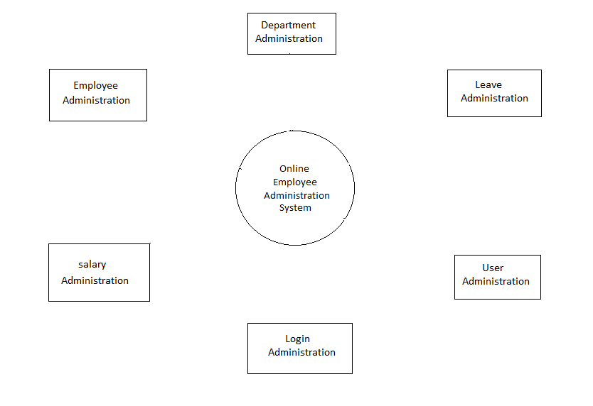

# Fig.7.2.1 Zero Level DFD

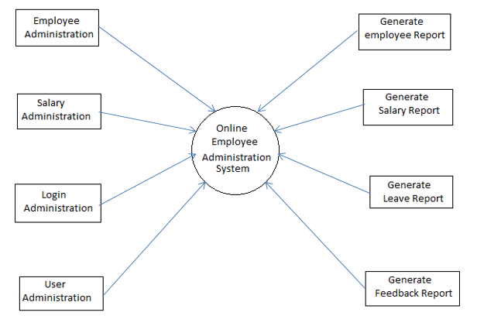

# Fig. 7.2.2 First Level DFD

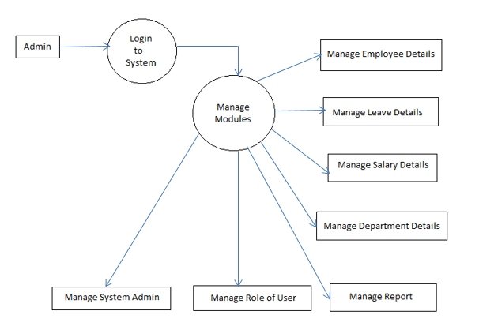

# Fig.7.2.3 Second Level DFD

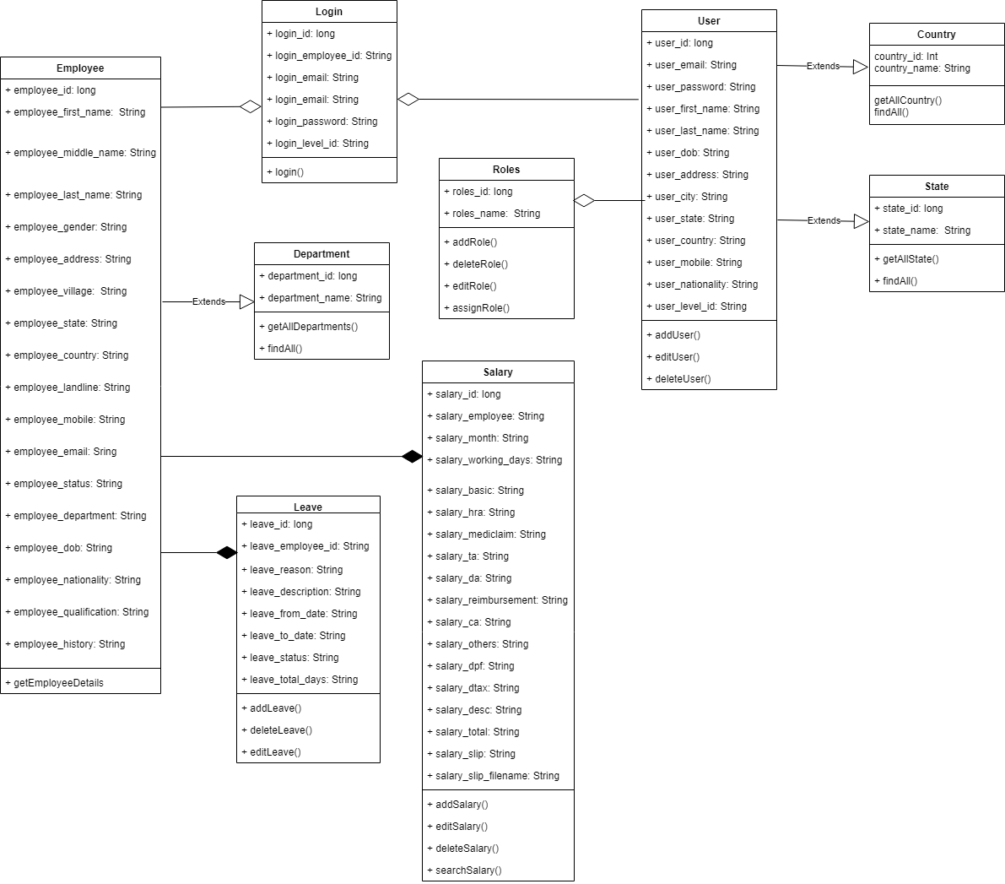

# Fig.7.3 Class Diagram

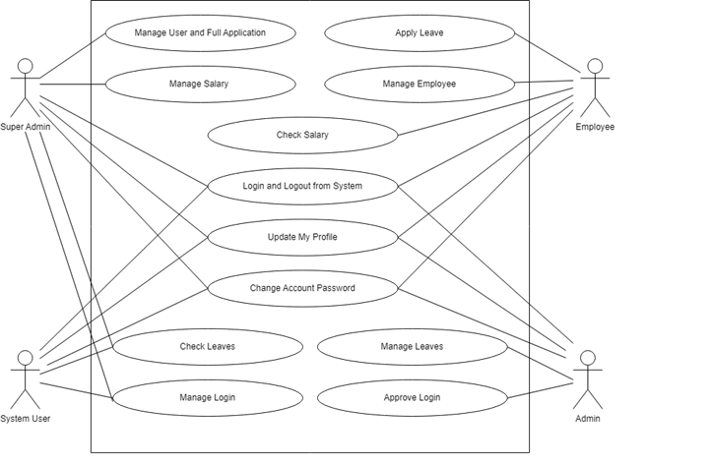

**Fig. 7.4 UseCase Diagram**

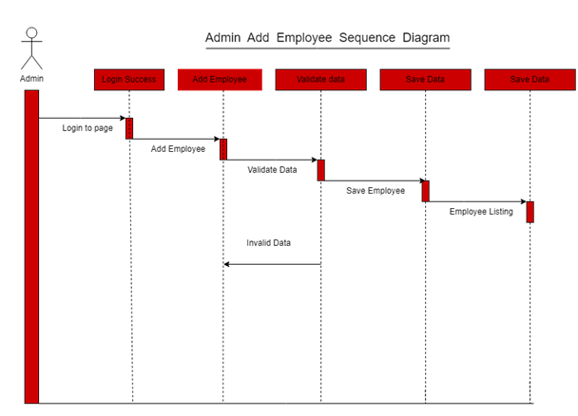

**Fig. 7.5.1** **Add Employee Sequence Diagram**

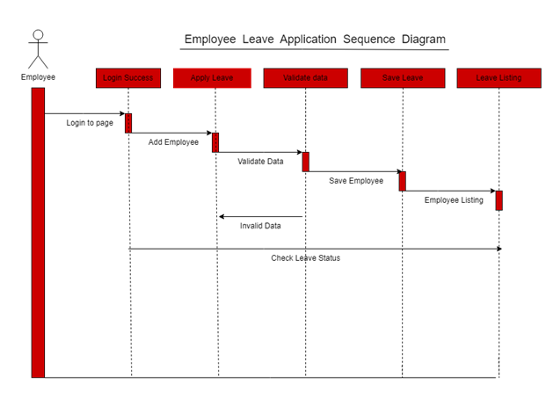

**Fig. 7.5.2** **Employee Leave Application Sequence Diagram**

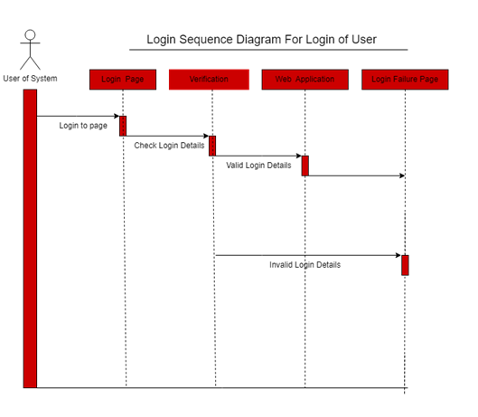

**Fig. 7.5.3** **Login of User Sequence Diagram**

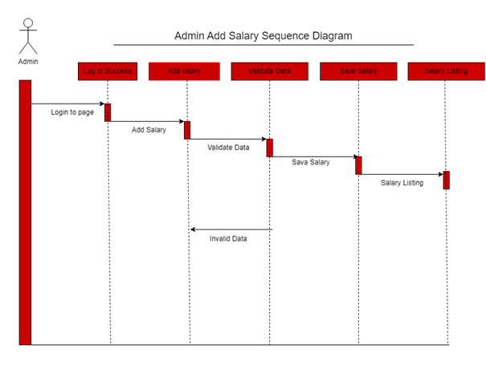

**Fig.7.5.4 Add Salary Sequence Diagram**

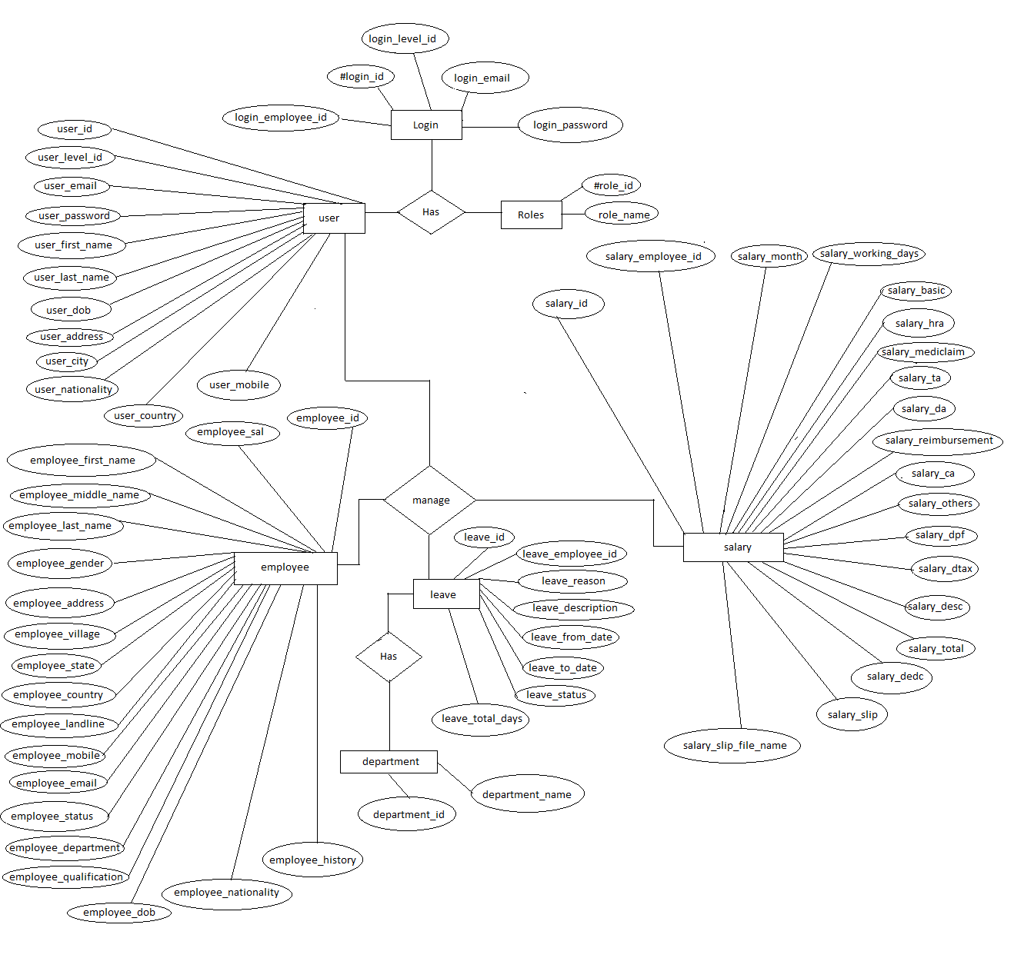

**Fig.7.6.1 ER Diagram**

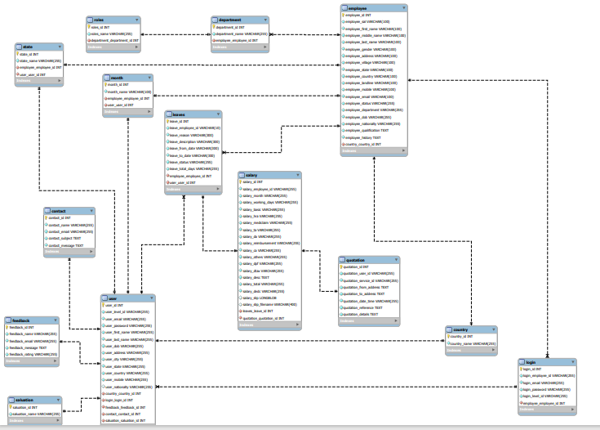

**Fig.7.6.2 ER Diagram System Generated**

1. **PROJECT SCREENSHOTS**

* **Home Page:**

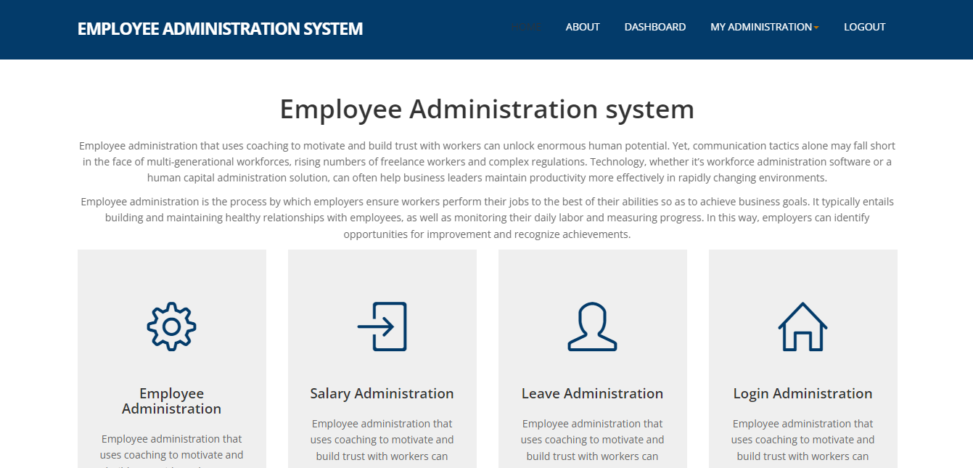 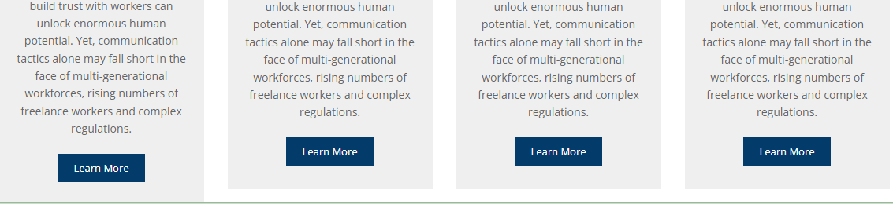 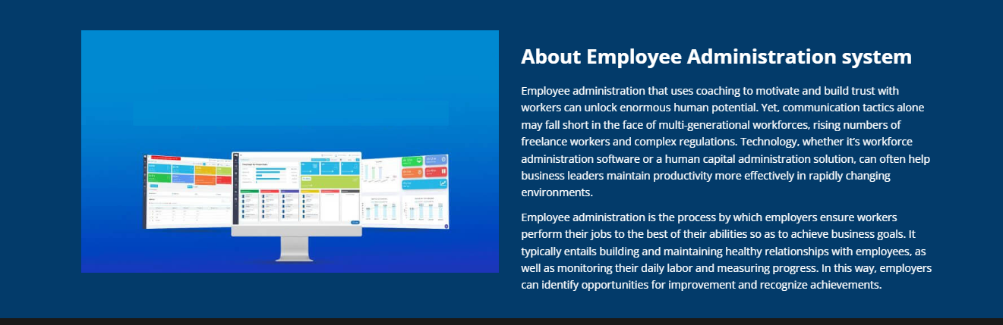

* **About Page:**

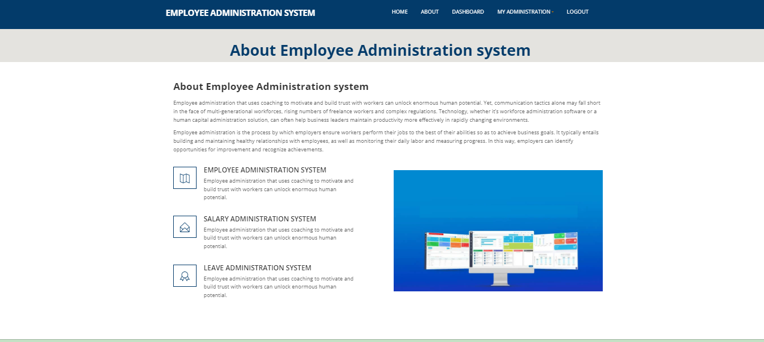

* **Admin Login:**

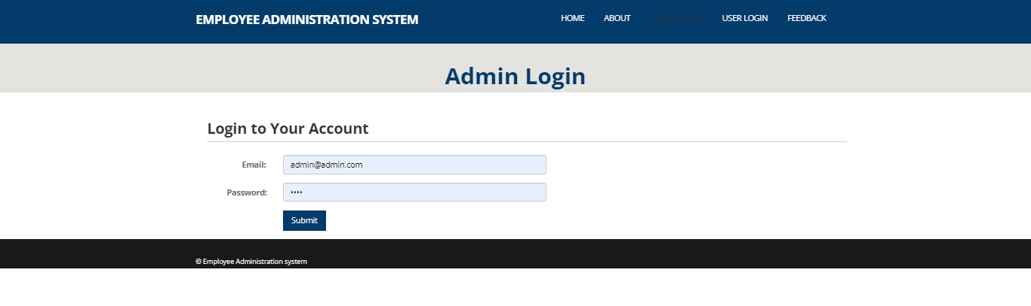

* **Employee Dashboard:**

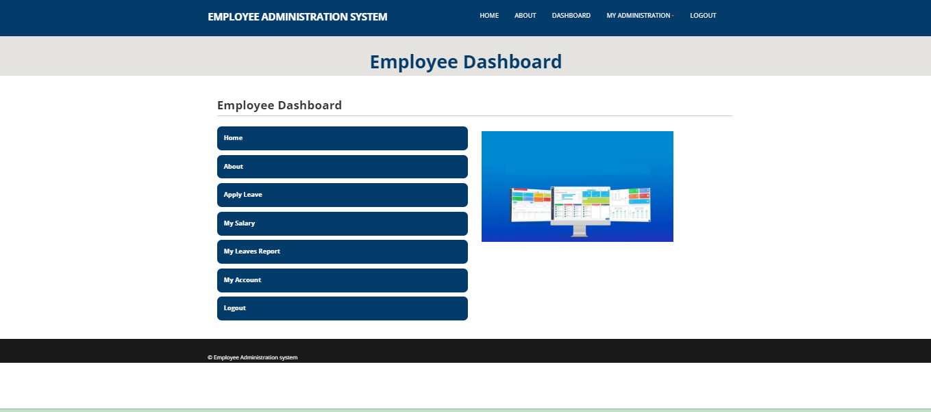

* **Add Employee :**

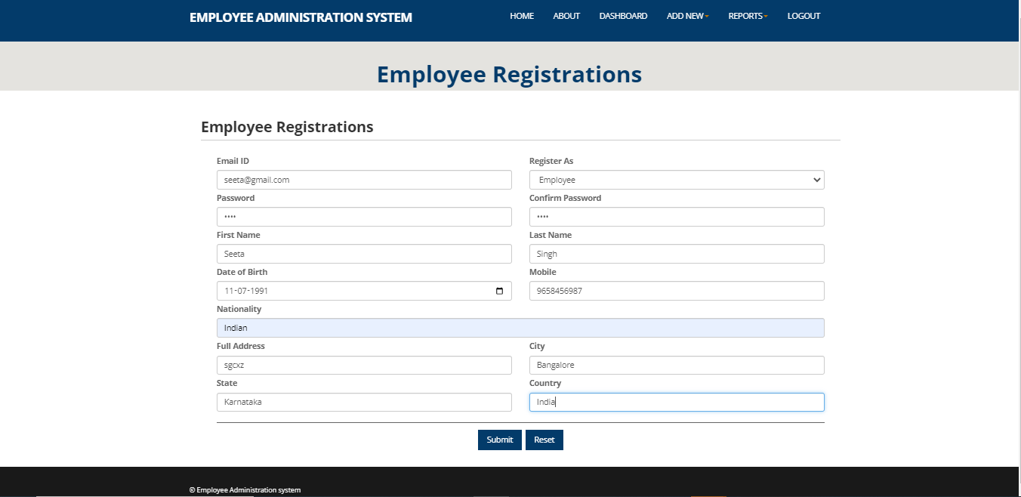

* **All Employee Report:**

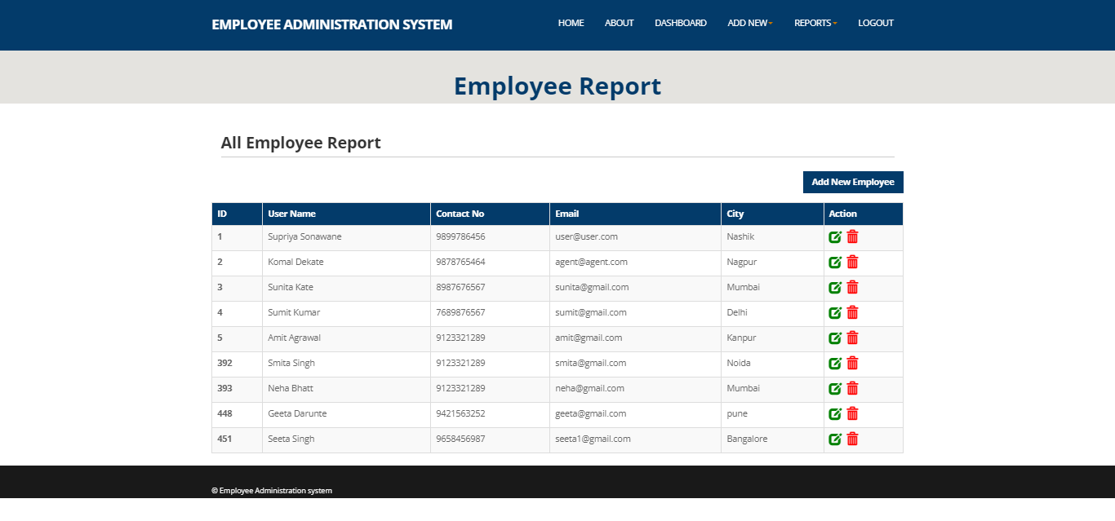

* **Add Salary of Employee :**

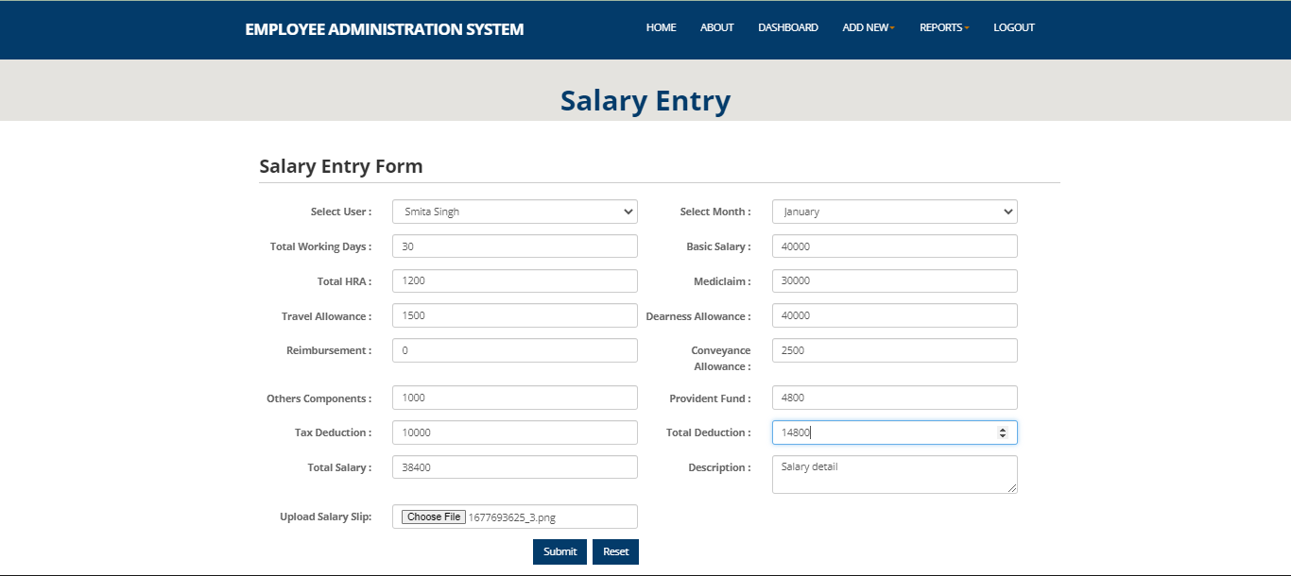

* **Salary Report of Employee :**

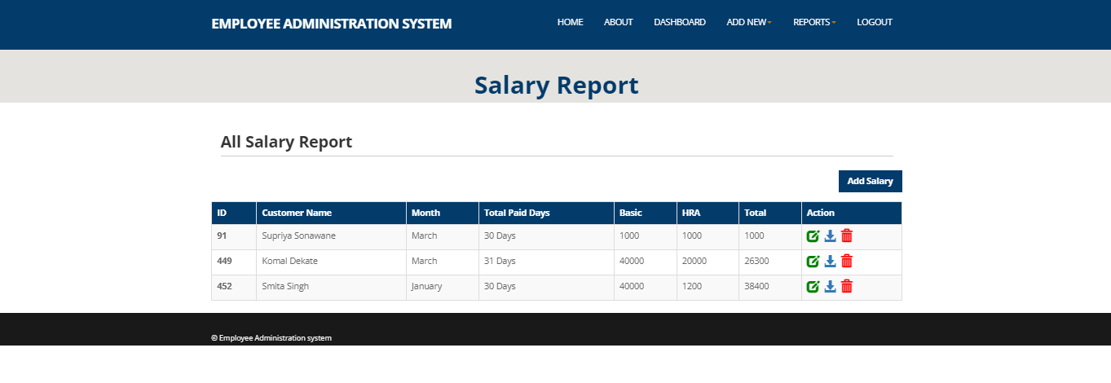

* **Leave Administration of Employee :**

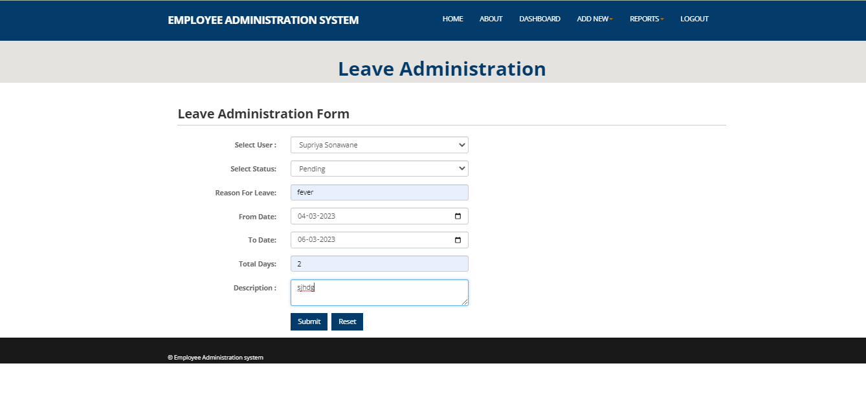

* **Leave Report of Employee :**

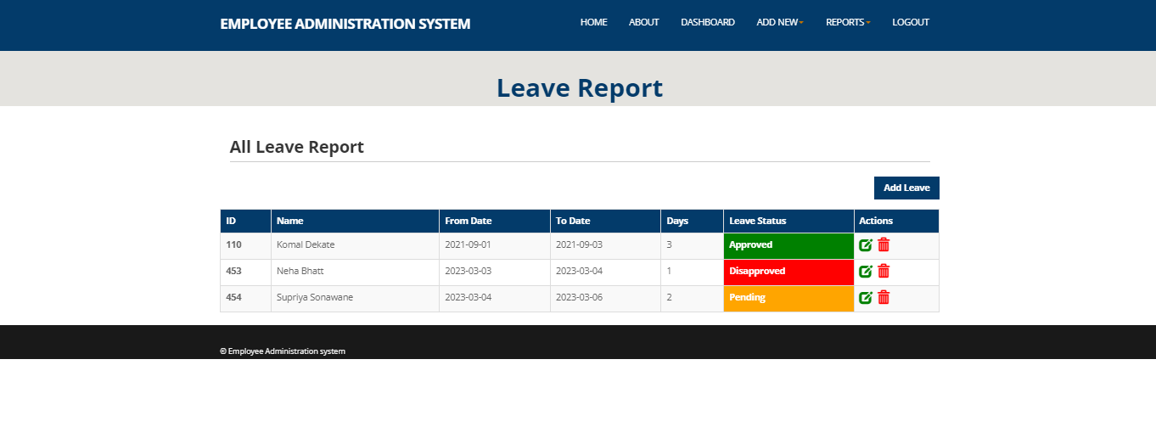

* **User Login:**

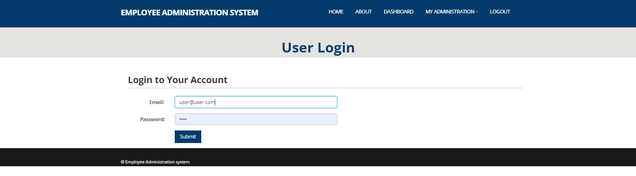

* **Employee Dashboard :**

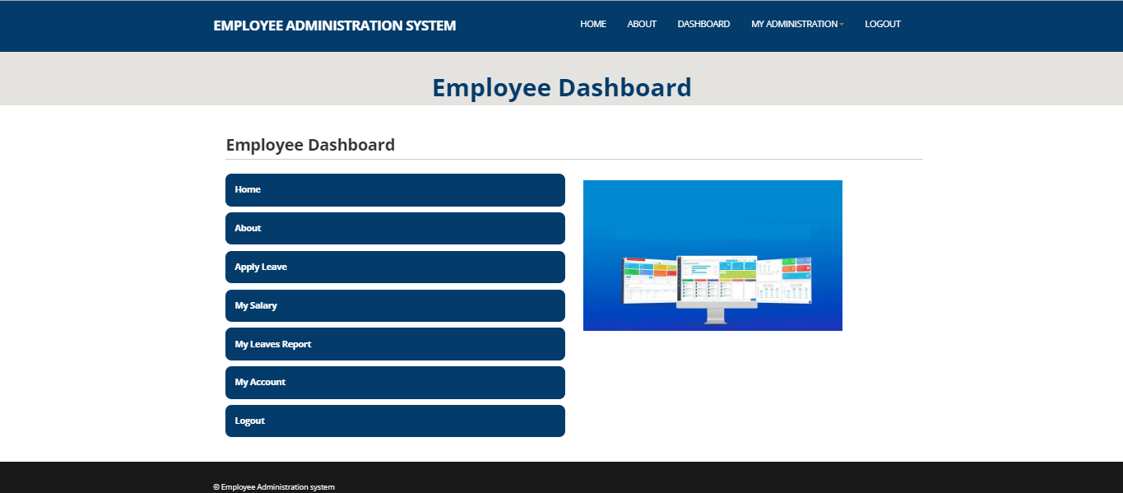

* **Apply for Leave:**

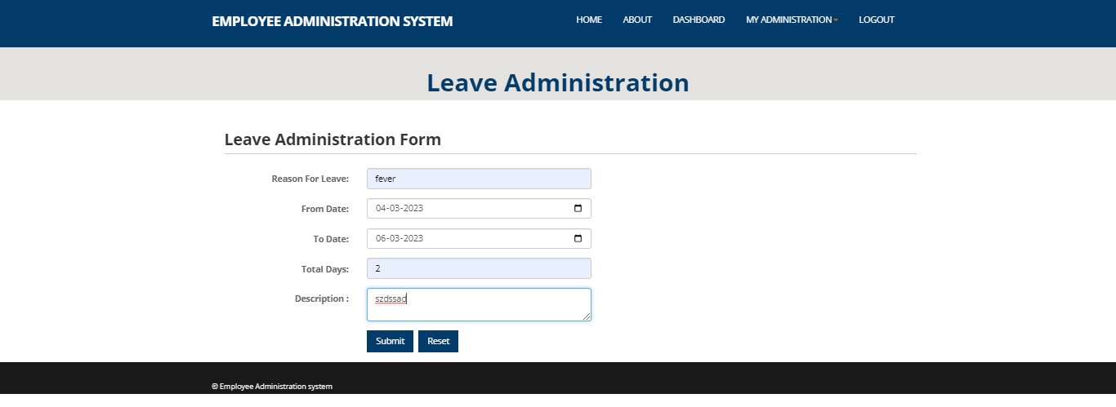

* **Leave Report of Employee :**

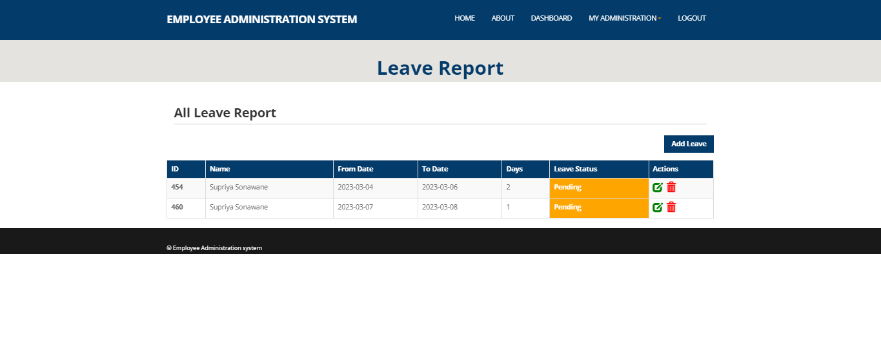

* **Salary Report of Employee :**

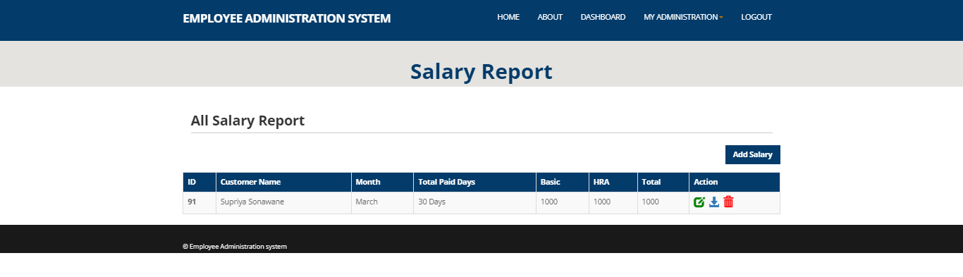

* **Update Employee Account :**

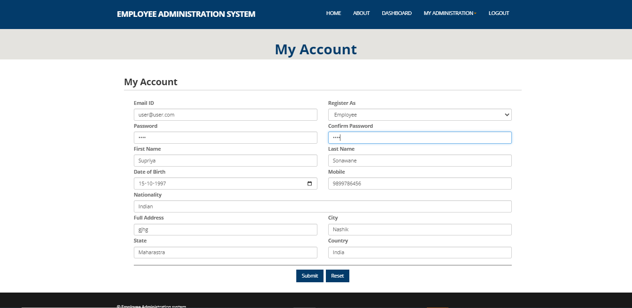

* **Employee Feedback Form:**

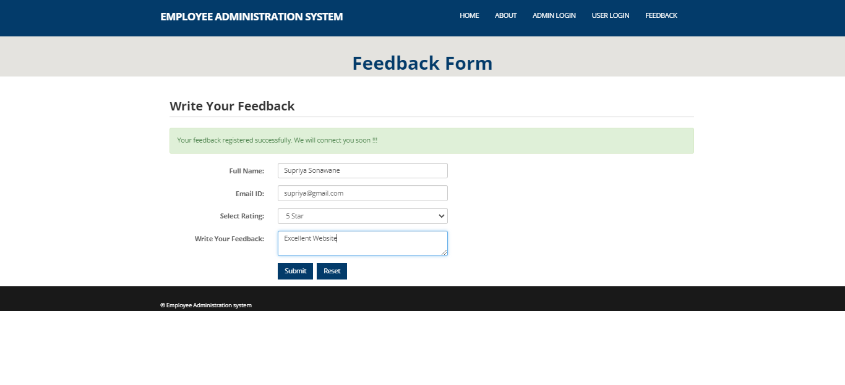

* **Feedback Report :**

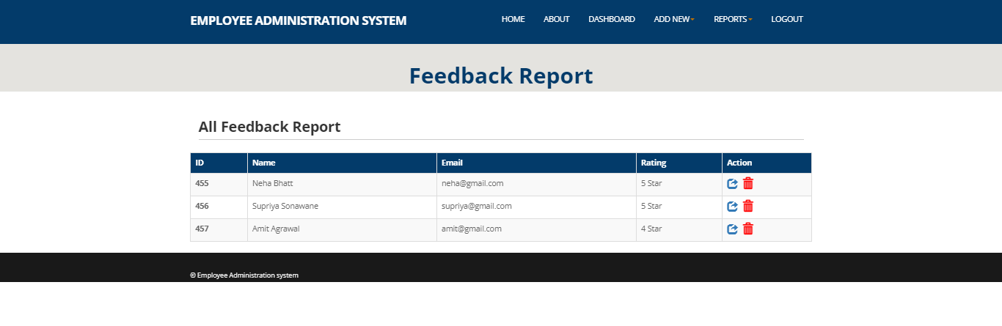

1. **CONCLUSION**

This dynamic website will provide information about employee administration system such as salary management, leave management, all employee details management and feedbacks.

Towards the end of project, the target which was initially set up was achieved to a good extent. The project made realise the significance of developing software for users, where the sole aim is to learn.

During the project, the real importance for following all principles of system analysis and design and necessity of goings through the several stages. As the initial investigation, now user can say that this application possible to created. But as project will progress there may some change in functionality of the project.

1. **FUTURE SCOPE**

* Automatic salary deduction as per the leave taken by employees.
* Attendance of employee can be added in the EAS system.
* SMS and Email facility to employee as salary credited can be future added in the EAS system

1. **REFERENCES**

[1] JavaScript Enlightenment, Cody Lindley-First Edition, based on JavaScript 1.5, ECMA-262, Edition

[2] Mc Graw Hill’s, Java: The complete reference 7thEdition, HerbertScheldt

[3] Complete CSS Guide, Maxine Sherrin and John Allsopp-O'ReillyMedia; September 201

**ONLINE REFERENCE**

[1] [www.Google.com](http://www.Google.com)

[2] [www.w3school.com](http://www.w3school.com)

[3] www.javatpoint.com